Dynamic Ballast - Initial Thoughts

Bob Noakes  
October 2, 2019

In order to reduce the constant vertical thrusting requirement for the UAV, it was proposed that a dynamic ballast system be conceptualized/designed. This would allow the vessel to submerge and surface by changing the ballast tank between air and water fill.

# Functional Requirements

* Submerge at the beginning of the run from surface to 10ft (3m) below water level
* Complete submerge operation in ??? seconds
* Remain submerged throughout the 30 minute trial period
* Surface at the end of the trial period
* Complete surfacing operation in ??? seconds
* Fit inside/on the submarine vessel and not interfere with the vessel operation
* Not pose a safety or damage risk from rupturing
* Others?

# Theory

The vessel size and mass should be designed to be approximately neutrally buoyant with the ballast tanks ~50% filled with water. The main variable affecting the magnitude of the submerging/surfacing force is the volume of the ballast tank.

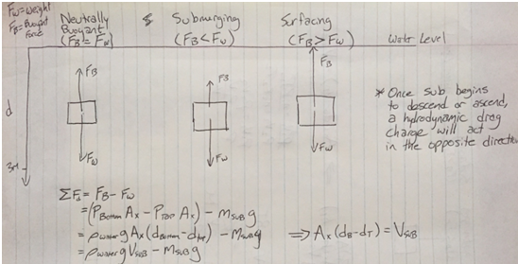

# Proposed operation

The buoyant force is equal to the weight of the displaced water. The system must be smart enough to fill up enough ballast to submerge at the desired speed, then partially purge to attain neutral buoyancy once the vessel reaches the target depth.

Surfacing is initiated by further or complete purging of water from the ballast tank. There must be enough pressure in the air tank to overcome hydrostatic pressure at the target depth and purge the water volume with a safety factor.

Here is a sample calculation with theoretical values. A 3L ballast tank provides a ~30N force window (15 for submerging, 15 for surfacing).

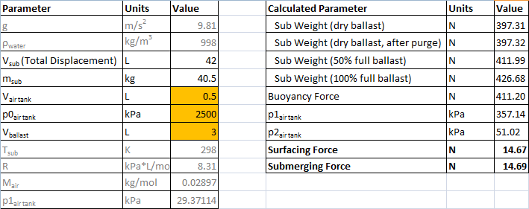

# Actions

* Find out what the hydrodynamic drag is at the required submerging/surfacing speed, determine size of ballast tankrequired
* Figure out what tank is the best option to contain the pressurized air
* Design a valve arrangement and control system
* Fit the tank into the vessel design